St. Matthew’s Episcopal Church

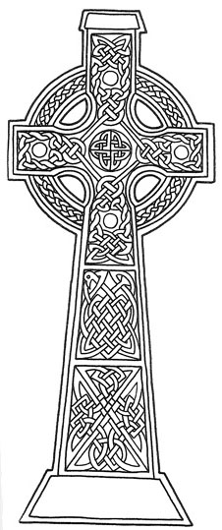

Sunday, April 21st, 2024
The Fourth Sunday of Easter
Communion in the Absence of a Priest
Worship at 10:15 am

Prelude
Processional Hymnal #577
“God is Love and Where True Love Is”
The Ministry of the Word
Opening Acclamation
Minister of the Word: Grace and peace. In the name of Christ.
People: Thanks be to God.
Glory to God in the Highest Hymnal #S-280
Collect of the Day BCP pg. 225

First Lesson (sit) Acts 4:5-12

Psalm 23 BCP pg. 612

Second Lesson 1 John 3:16-24
Sequence Hymn (stand) Hymnal #645 vs 1, 2
“The King of Love My Shepherd Is”
Gospel John 10:11-18
Sequence Hymn (stand) Hymnal #645 vs 3, 4
“The King of Love My Shepherd Is”
Proclamation (sit)
Nicene Creed BCP pg. 358
Prayers of the People Form IV BCP pg. 388
Confession
Have mercy upon us, most merciful Father; in your compassion forgive us our sins, known and unknown, things done and left undone; and so uphold us by your Spirit that we may live and serve you in newness of life, to the honor and glory of your Name; through Jesus Christ our Lord. Amen.
The Peace (stand) BCP pg. 360
Announcements
Offertory
Doxology Hymnal #380 v.3
The Ministry of the Table
Minister of the Table: God be with you.
People: And also with you.
Minister of the Table: Let us pray.
The Lord’s Prayer BCP pg. 364
Holy, Holy, Holy Hymnal #S-129
The Prayer of Humble Access
Most merciful Lord, your love compels us to come to your table. Our hands were unclean, our hearts were unprepared. We were not fit even to eat the crumbs from under your table. But you, Lord, are the God of our salvation and share your bread with sinners. Cleanse and feed us with the precious body and blood of your Son, so that he may live in us and we in him; and that we, with the whole company of Christ, may sit and eat in your kingdom. Amen.
Communion
Post Communion Hymn Hymnal #304
“I Come With Joy to Meet My Lord”
Post Communion Prayer
Loving God, we give you thanks for restoring us in your image and nourishing us with spiritual food in the Sacrament of Christ Body. Now send us forth a people, forgiven, healed, renewed; that we may proclaim your love to the world and continue in the risen life of Christ our Savior. Amen
Minister of Reserved Sacrament: Let us bless the Lord
People: Thanks be to God.
May the God of hope fill us all with joy and peace in believing through the power of the Holy Spirit, Amen.
Recessional Hymnal #518
“Christ Is Made the Sure Foundation”
Dismissal
Postlude

Ministers this Service
Minister of the Word: Mary Anne McCloud, Maggie Snow
Lector: Jeremy Kitto
Ushers: Rick Glover, Mary Werner
Counters: Mary Upton, Fred Schroeder
Organist: Chris Teichler
Videographer: Ben Teichler
Altar Guild: Twila Lockaby, Scott McCloud, Ruth Cooper, Maggie Snow

Altar Flowers: Steve and Darla Stonehouse
“For blessings received”

St. Matthew’s Episcopal Church
2001 Windsor Drive
P.O. Box 342
Newton, Kansas 67114

Phone:
316.283.3310
Website:
www.stmatthewsnewton.org
Office Email:
office.stmatthewsnewton@gmail.com
Social Media:
www.facebook.com/stmattsnewton/
https://www.youtube.com/@stmatthewsepiscopalnewton

Prayer List
Conner Ekerberg
Jordan Orr
Ryan Bernard
Nyla
Jim
Shayne
Steve
Donna
Larry

Calendar

TODAY
Capital Campaign Mtg

Wednesday
Evening Prayer 6:30 p.m.
EFM, 7 p.m.

Thursday
Diocesan Book Study, 7 p.m., Zoom Meet

Friday
A.A. meeting, lounge 6:30 p.m.

Sat, Apr 27
Parish Council Mtg, 10 a.m.

Sun, Apr 28
PEF Mtg after service

